**38.AWS-ACM & Route53 & 3rd Party SSL Cert**

Here I am going create 2EC2 instances, add these instances to load balancer then I will add load balancer to a Route 53.

**AWS Certificate Manager**

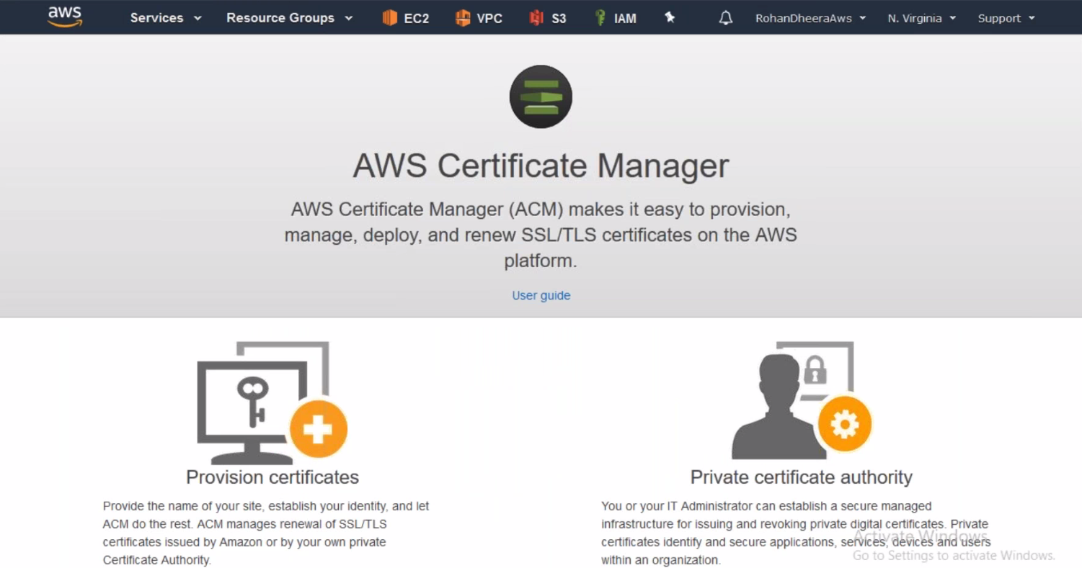

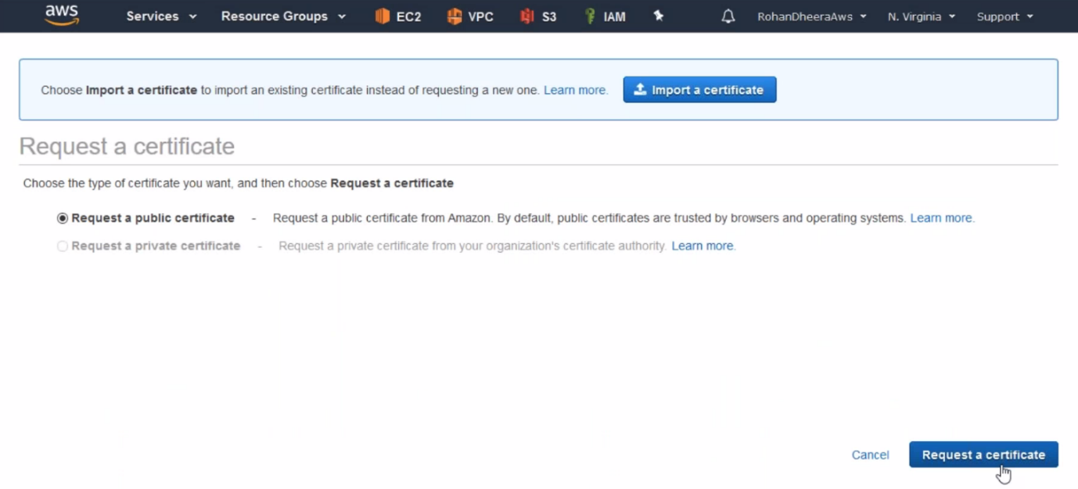

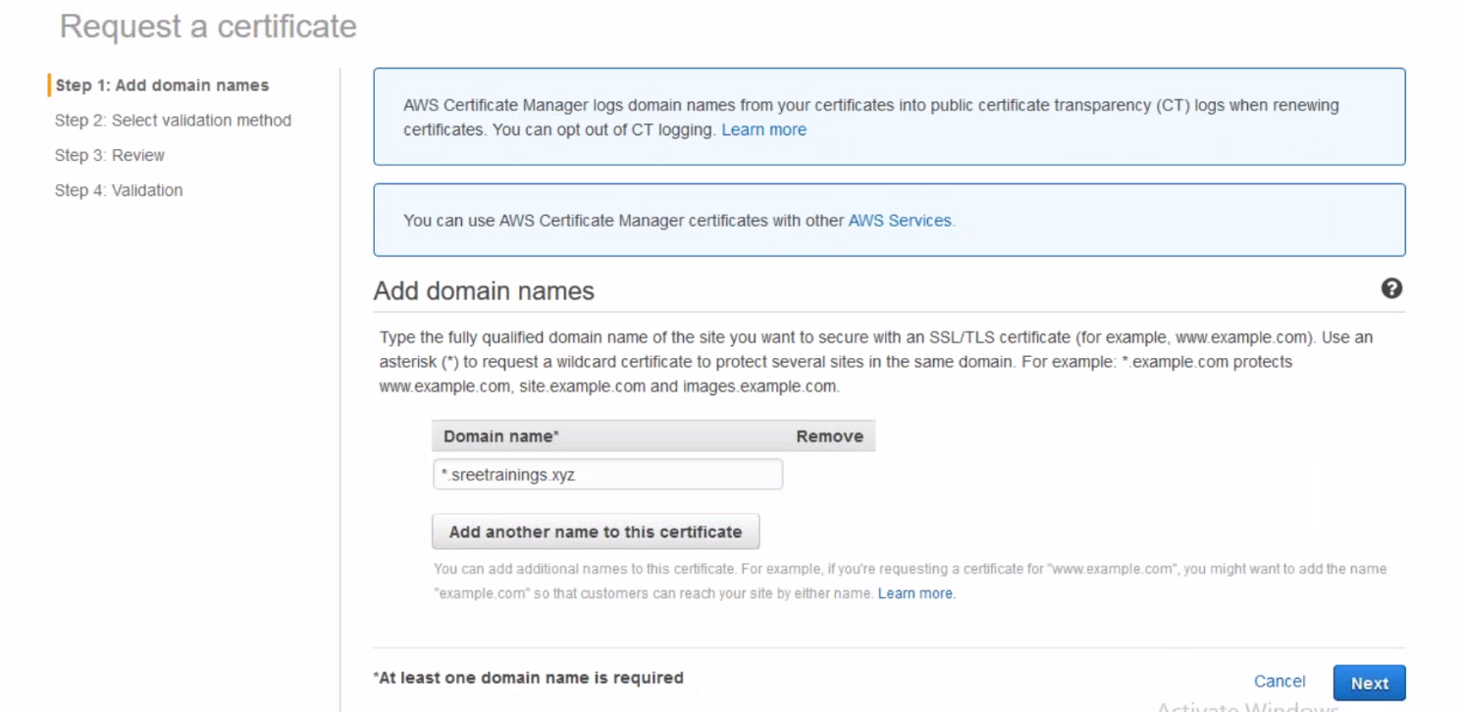

--- given website name in Route 53.

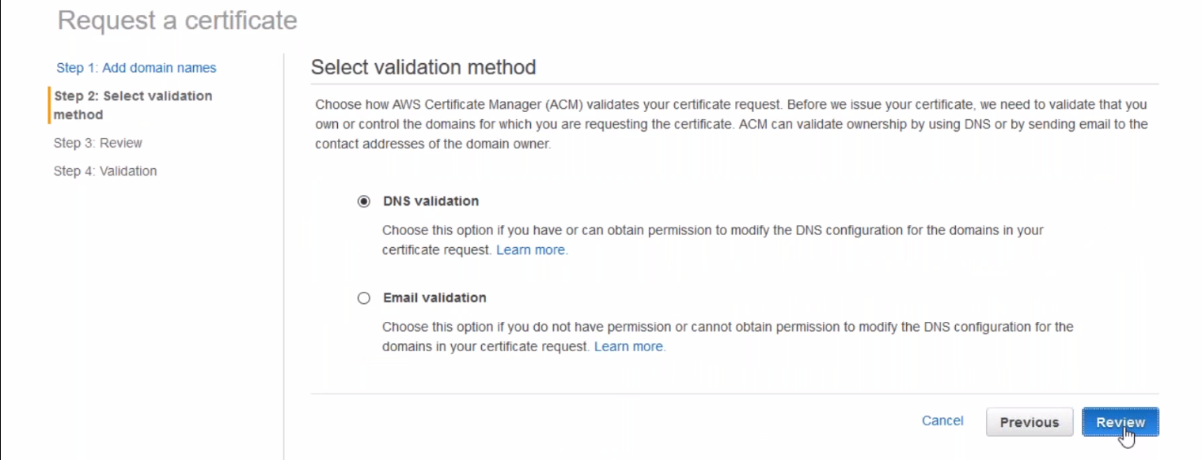

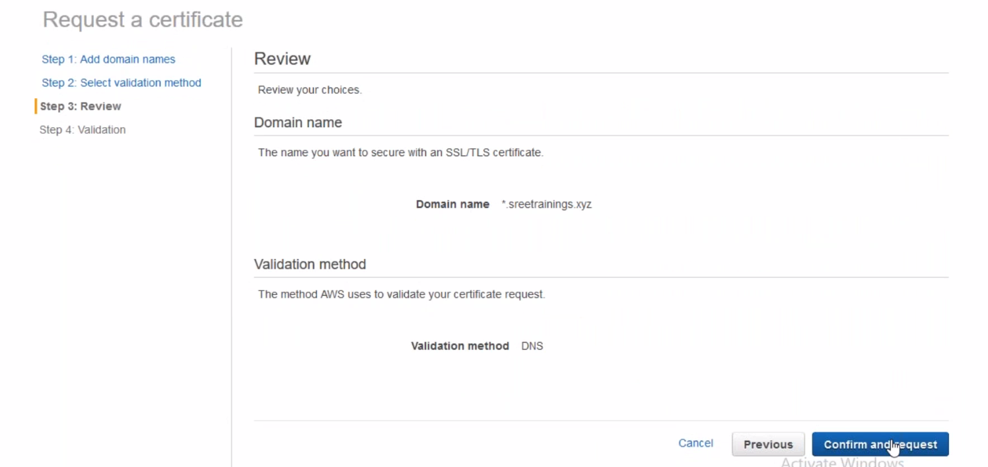

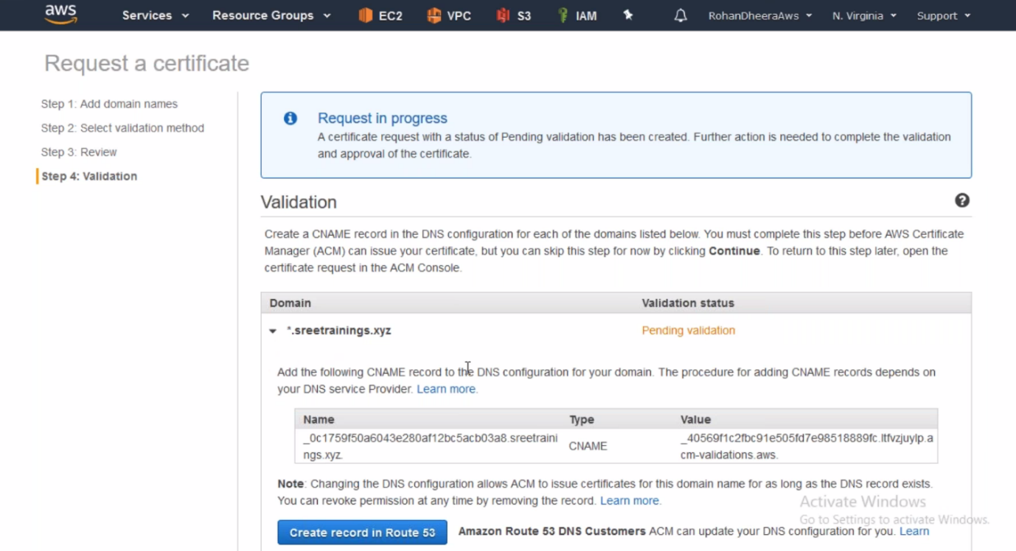

--- here we will get validation pending, it will ask you if you’re the owner of this site then create a record set in Route 53.

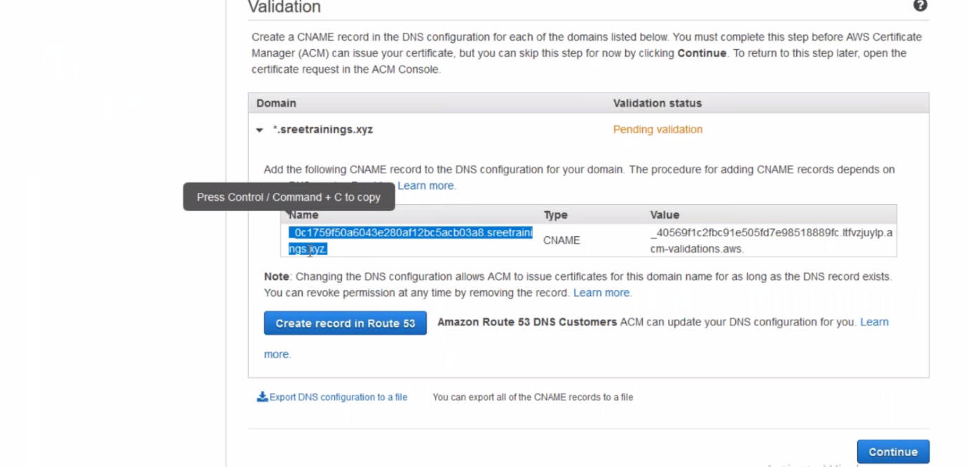

--- copy this line and use it to create a record set.

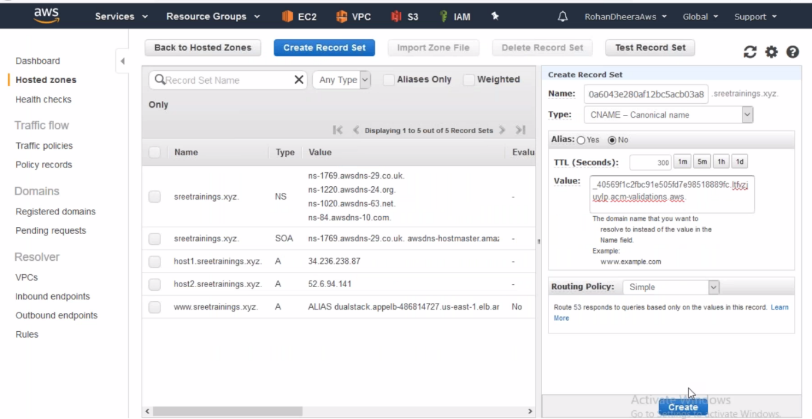

--- copy the value from AWS certificate manager and paste it here and then click on create it.

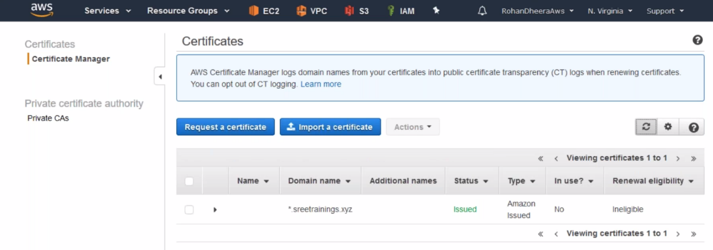

--- after you created a record set in Route 53, the pending request in AWS certificate manager will get successful

--- this certificate is given by AWS and we can use this certificate in AWS not for any other platform. This certificate is free.

--- we can also import 3rd party certificate.

**Updating AWS certificate in load balancer**

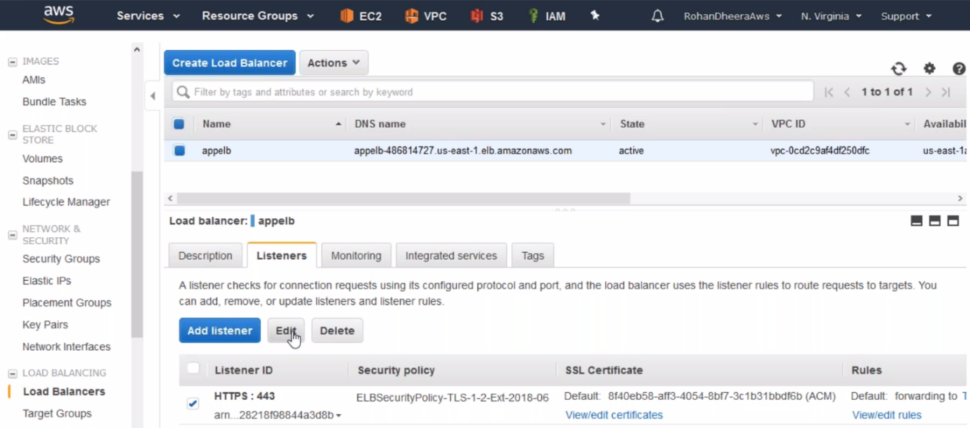

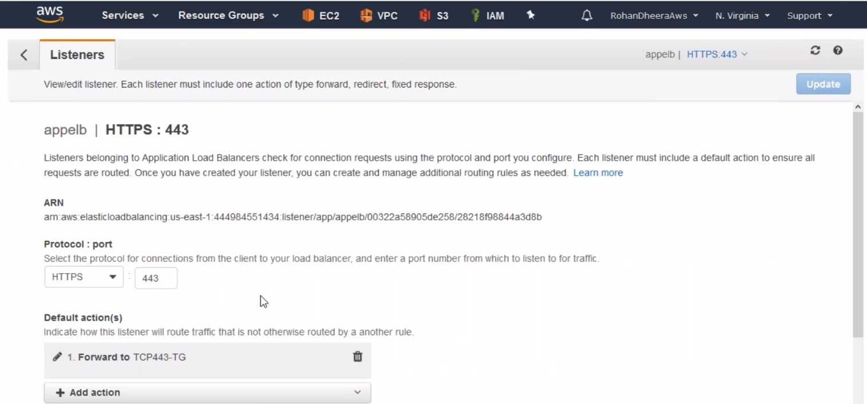

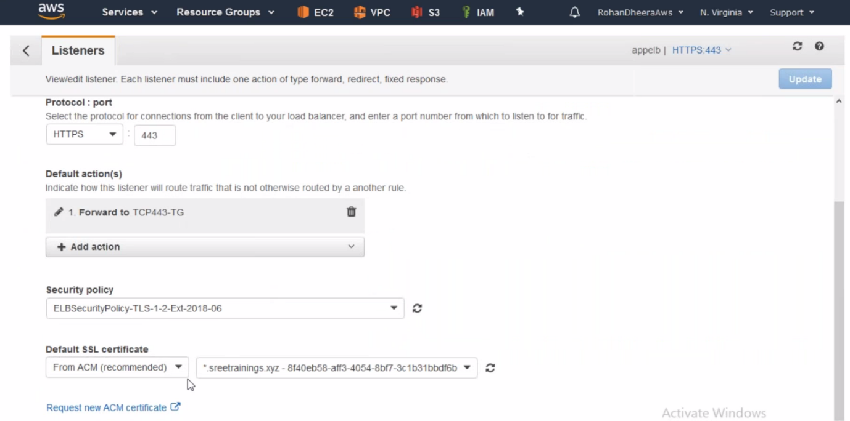

--- same here instead of ACM select import option.

**3rd Party SSL Certificate**